CV ZONE CONTROL 1.0

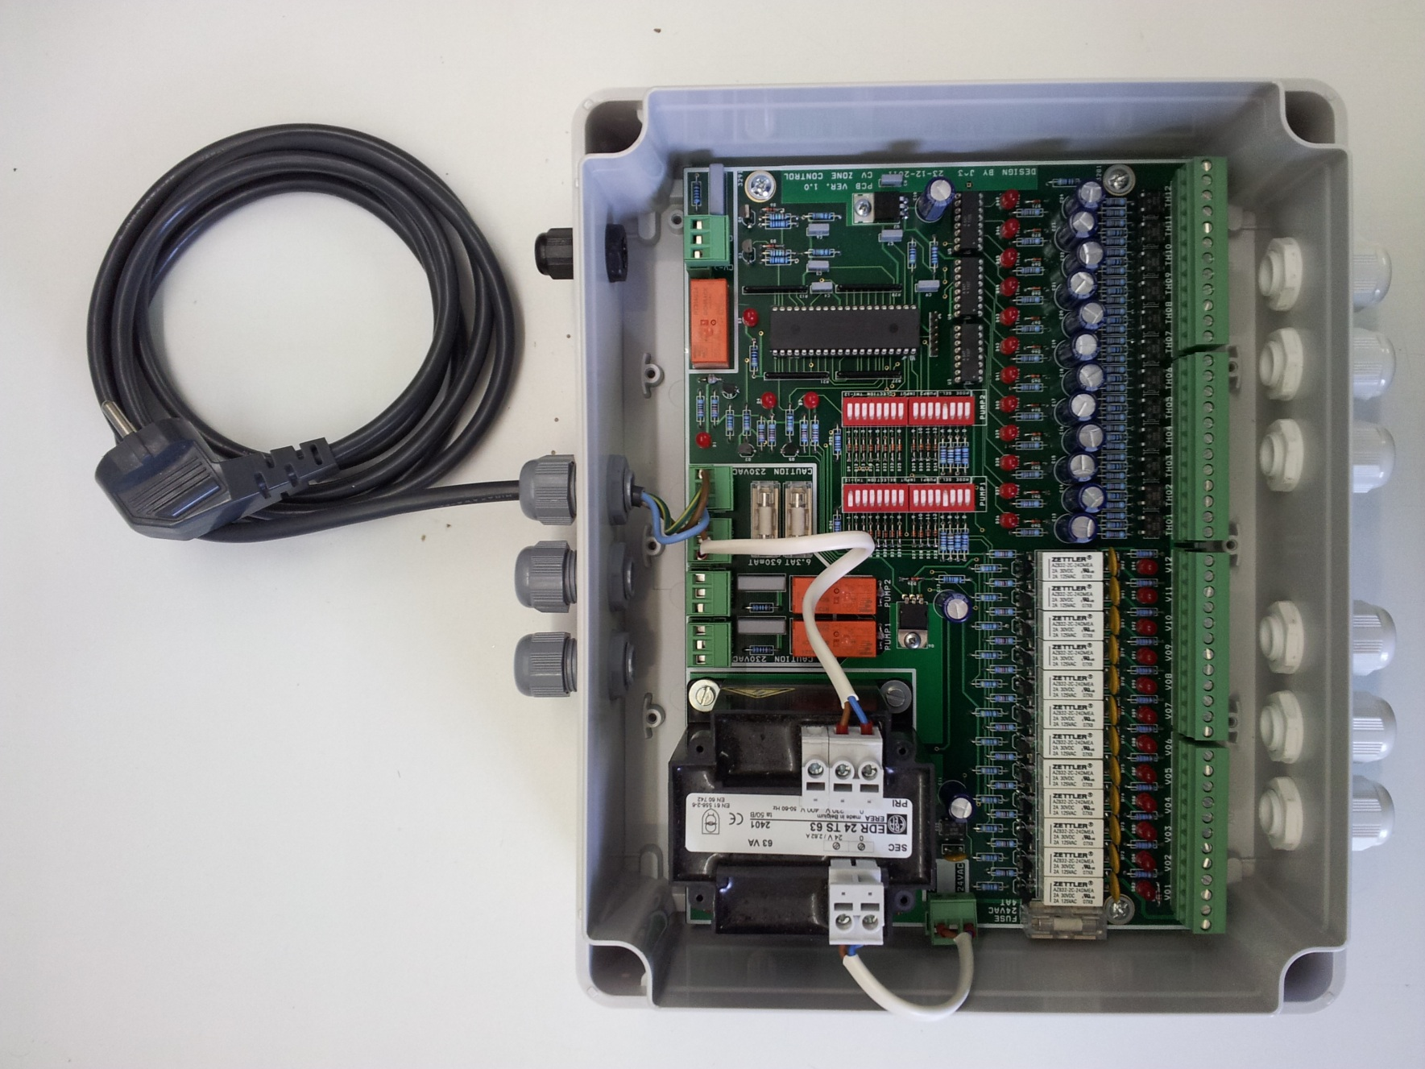

# Cv zone control power connection and circuit breaker values

Connect the cv zone control unit to an available wall outlet which is protected by a circuit breaker of 16A, a RCD (Residual Current Device) of 30mA and has an earth grounding connection.

**L1 PE N**

# 

# Connecting the valves and thermostats

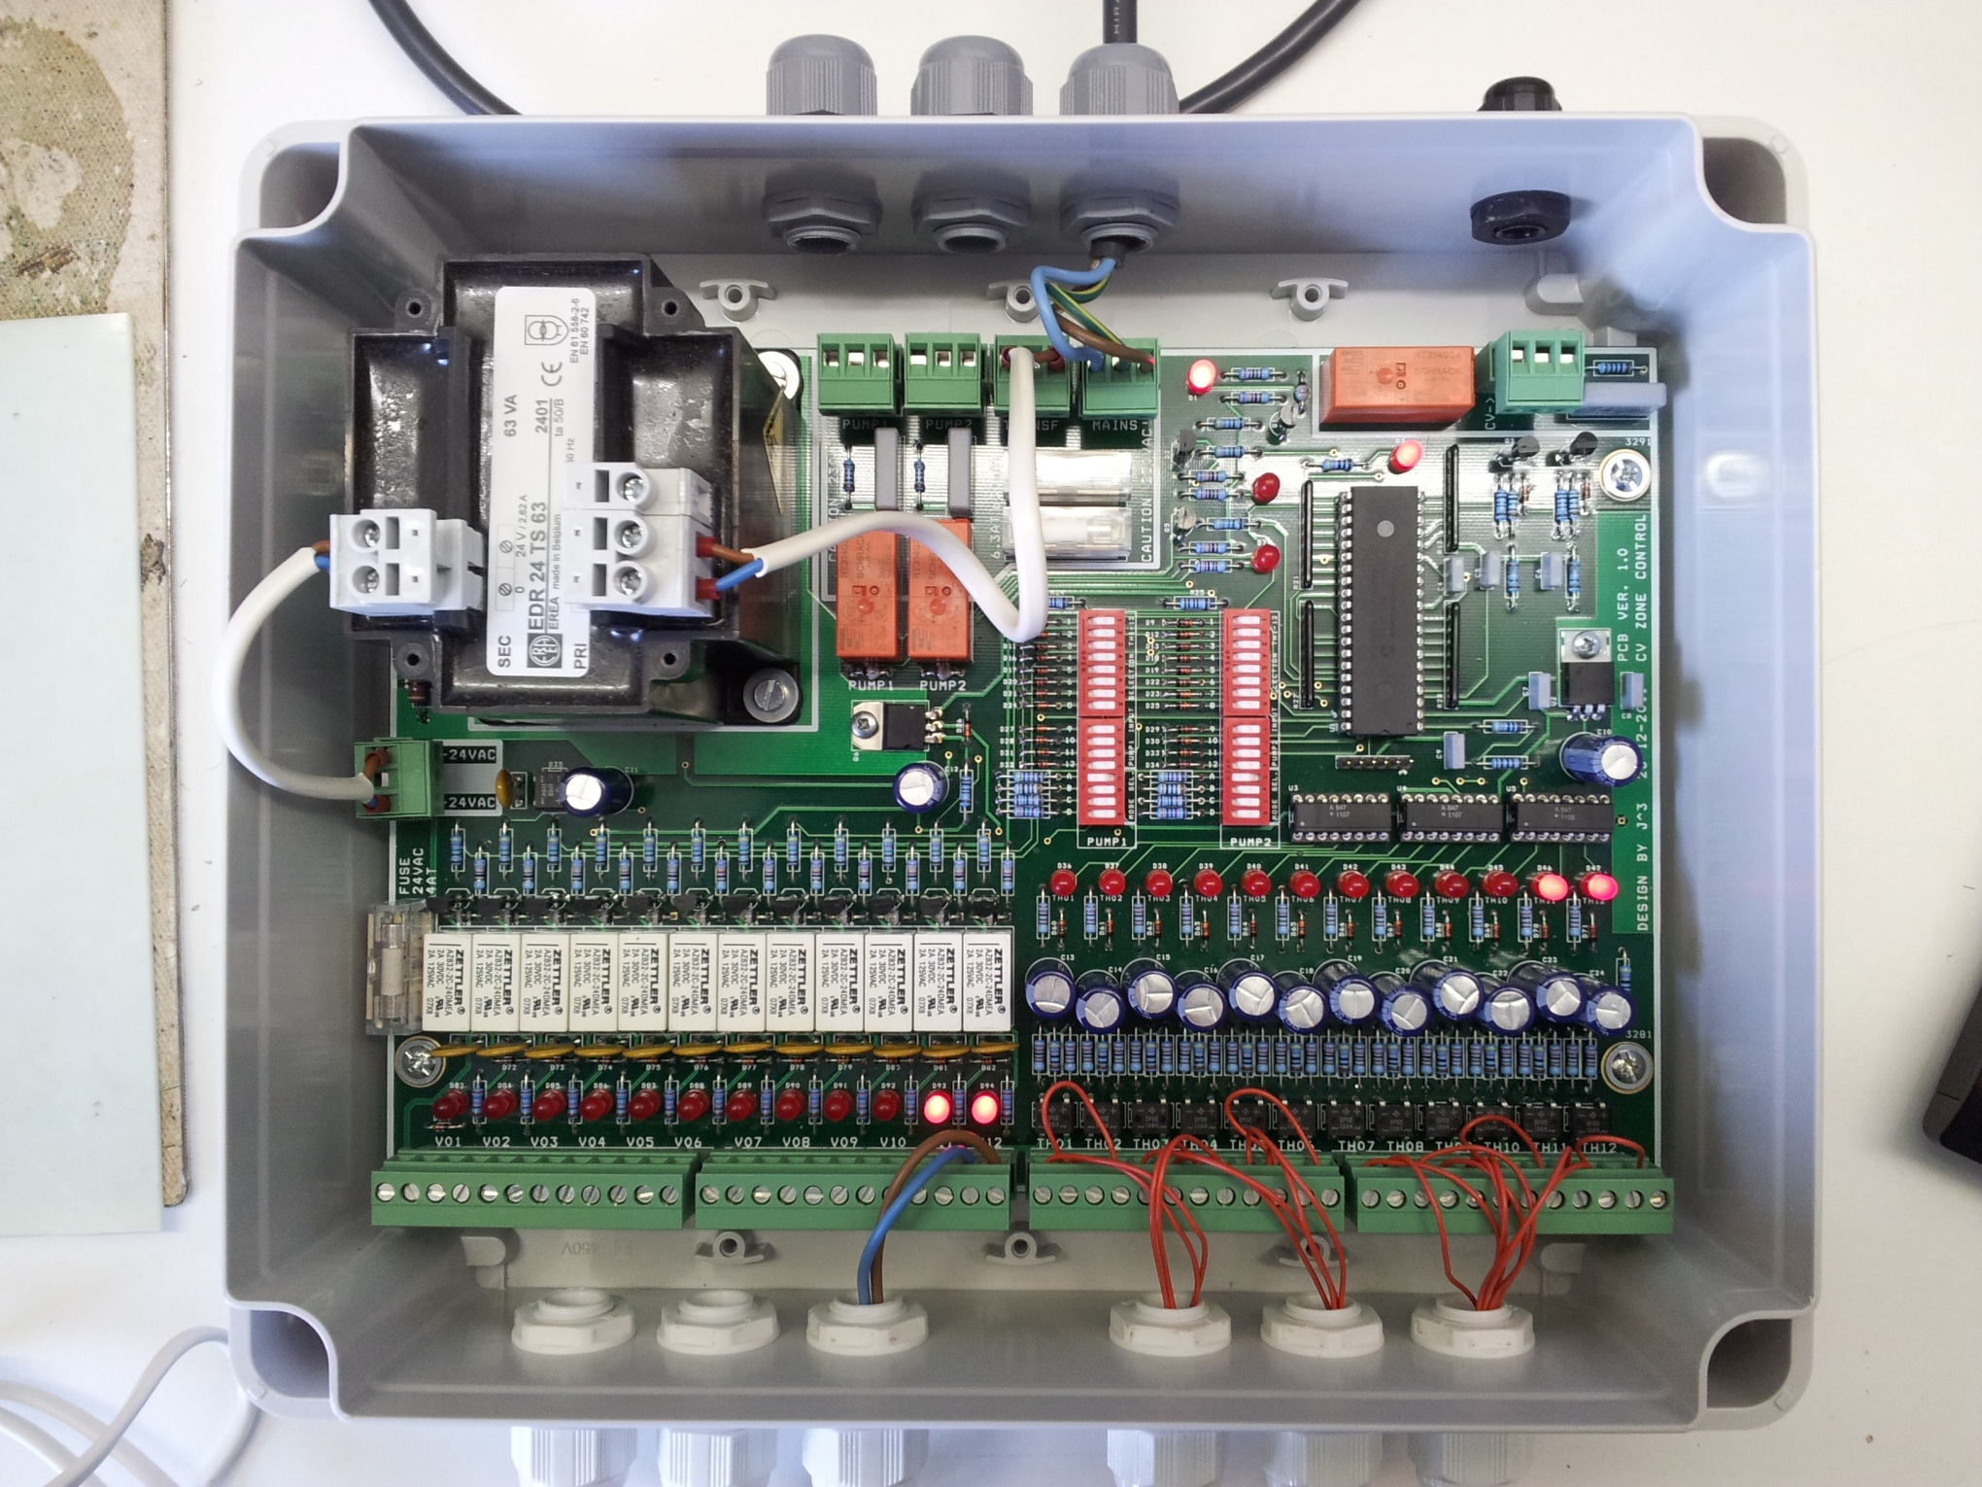

Thermostat

VALVE

24VAC

ACIN1

ACOUT1

0VAC

 

**Valve ON/OFF behavior**

When a thermostat is switched, the corresponding valve is switched ON after approximately 4 seconds. In the first 1 minute a valve output is switched ON, al other valve output enabling is delayed with 1 minute due to current inrush protection.

When the thermostat of an enabled vale is disabled, the corresponding valve will be switched off within approximately 2 minutes.

If a thermostat is the last to be disabled, the corresponding valve output will be switched OFF with a delay of 10 minutes to allow after circulation of heating water by central heating pump.

**Thermostat cascading**

It is allowed to cascade multiple thermostat inputs after 1 thermostat. However the valve outputs are enabled with 1 minute inrush protection after each other. When this group of valves is switched off as last, 1 output will remain ON for 10 minutes.

# Connecting floor heating pumps

L1  
PE  
N

Pump  
230VAC  
400VA max

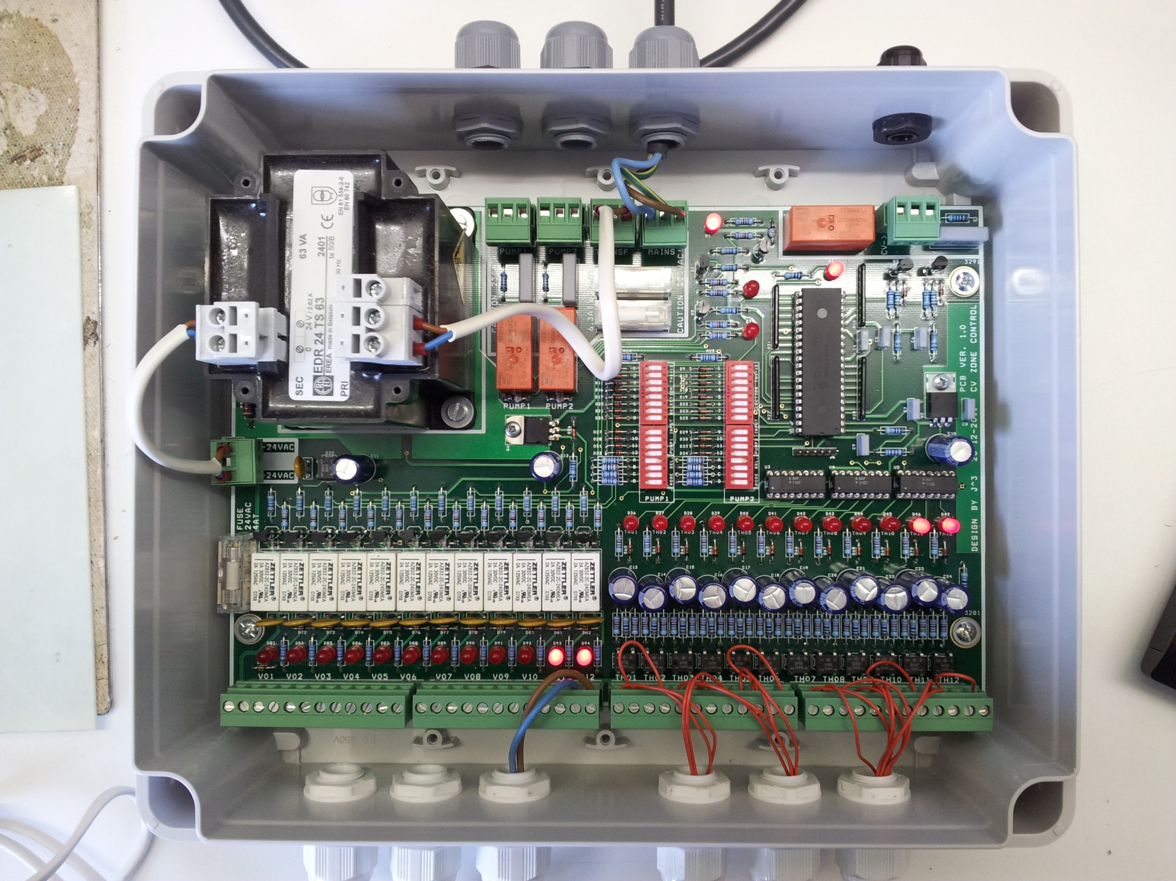

Pump2 LED

Pump1 LED

# Connecting central heating unit potential free NO contact



Central heating NO contact

Central heating LED

# Floor heating pump settings

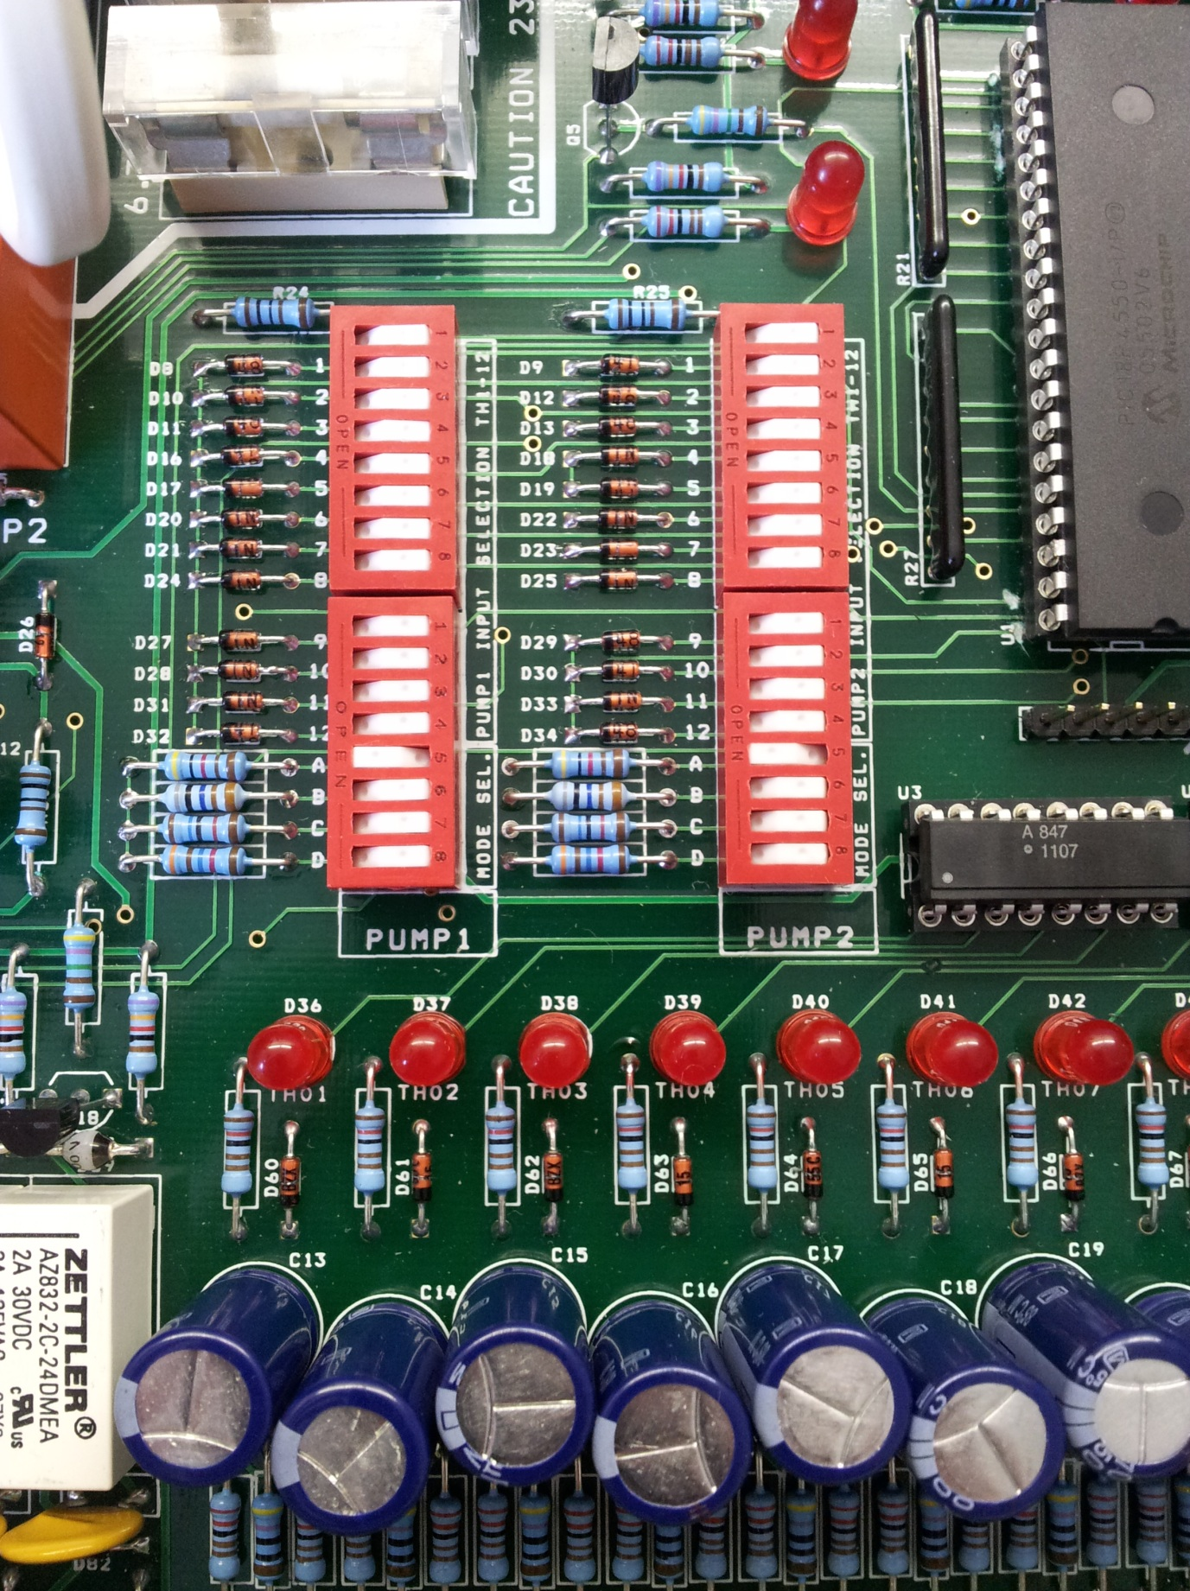  
**When a switch is switched towards “----OPEN-----” (to the left) the contact is OFF.**

Pump delayed OFF time

Pump protection ON/OFF

Thermostat selector

**Thermostat selector**

Use the first 12 switches to select which thermostat may enable the floor heating pump.  
When a valve output is switched ON, the selected pump will also be switched ON if selected.

**Pump protection ON/OFF**

Set this switch to ON to enable the pump protection timer. When no valve is switched within 24 hours, the pump will run automatically for 1 minute.

**Pump delayed OFF time**

With these 3 switches 4 settings can be set regarding pump delayed OFF time:

1. All switches OFF, pump delay OFF time is 2 minutes.
2. Switch 6 to ON (switch 7 and 8 OFF), pump delay OFF time is 10 minutes
3. Switch 7 to ON (switch 6 and 8 OFF), pump delay OFF time is 20 minutes
4. Switch 8 to ON (switch 6 and 7 OFF), pump delay OFF time is 30 minutes

Pump delayed OFF time starts after the last valve has been closed.

# Maximum ratings cv zone control

* Maximum connectible valves (3Watt nom/valve) : 20 valves
* Maximum connectible valves per output : 3 valves
* Maximum no of thermostat cascading : 12 thermostats
* Valve output voltage : 24 Vac
* Maximum valve output current : 900 mA
* Thermostat switching voltage : 24 Vac
* Thermostat switching current : 20 mA
* Cv zone control idle power consumption : 7.5 Watt
* Cv zone control maximum power consumption : 70 Watt
* Main circuit breaker : 6.3 A T
* Transformer circuit breaker : 630 mA T
* Valve output supply circuit breaker : 4 A T